Classification

w and b are parameters that affect the computation of what probability is of y = 1 given input x

Cost function for logistic regression

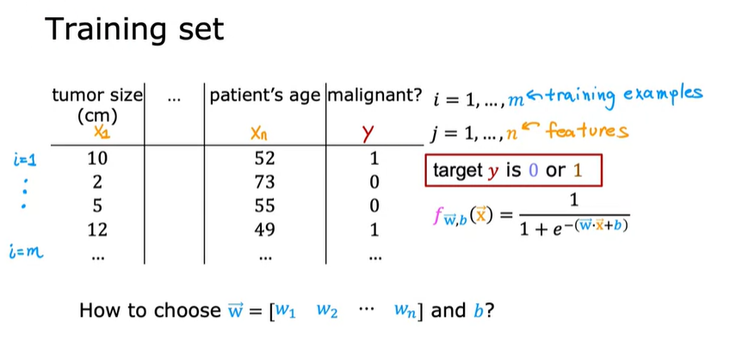

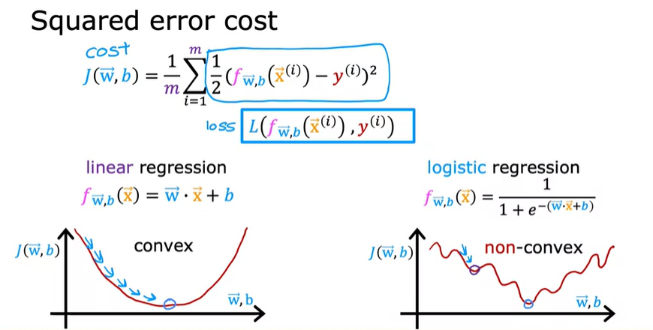

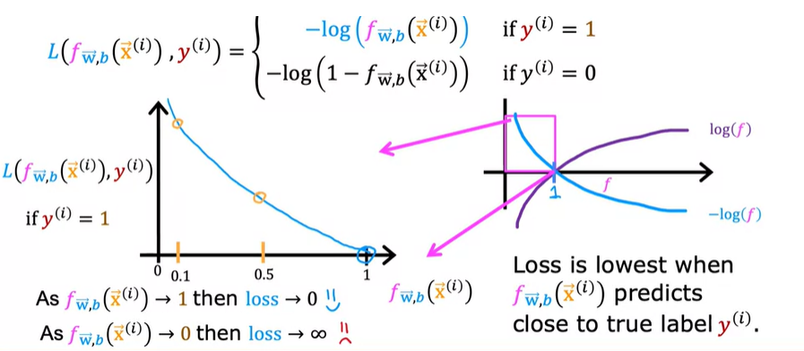

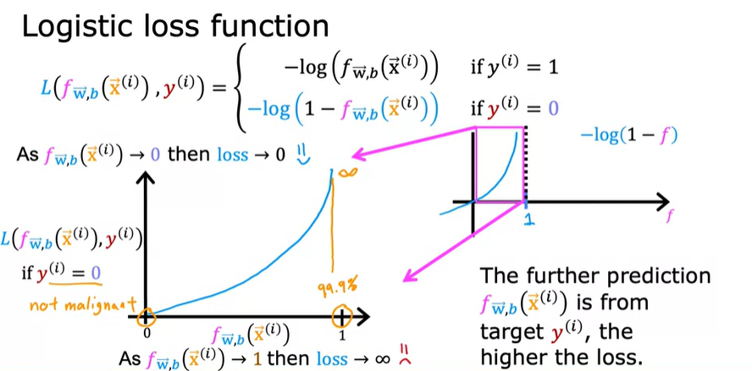

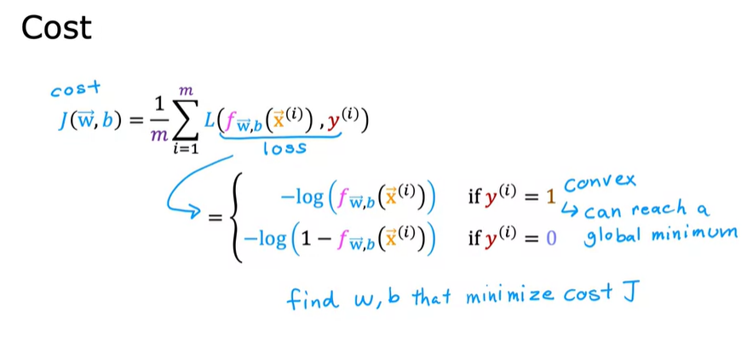

Simplified Cost Function for Logistic Regression

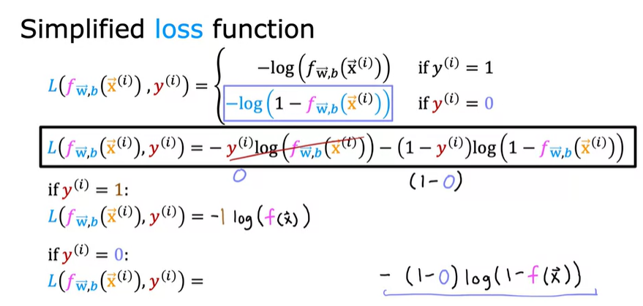

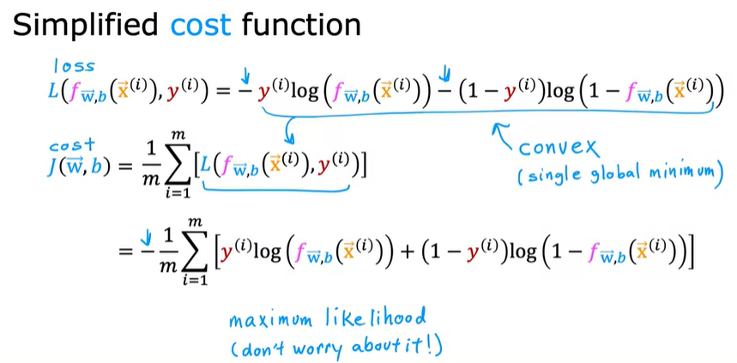

Gradient Descent Implementation

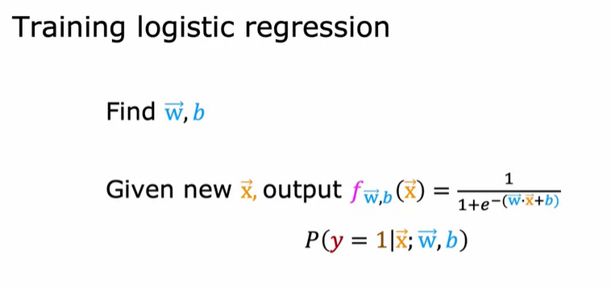

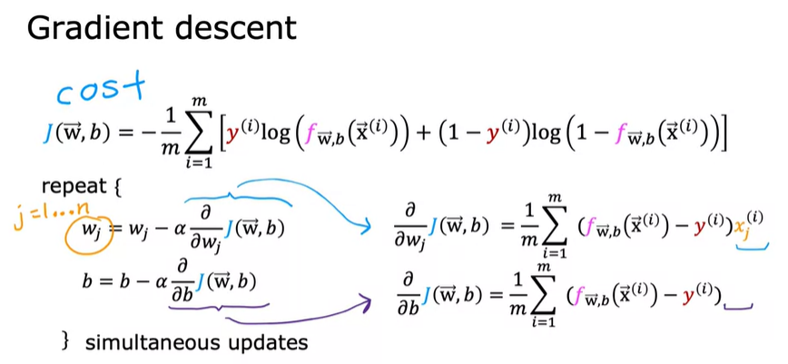

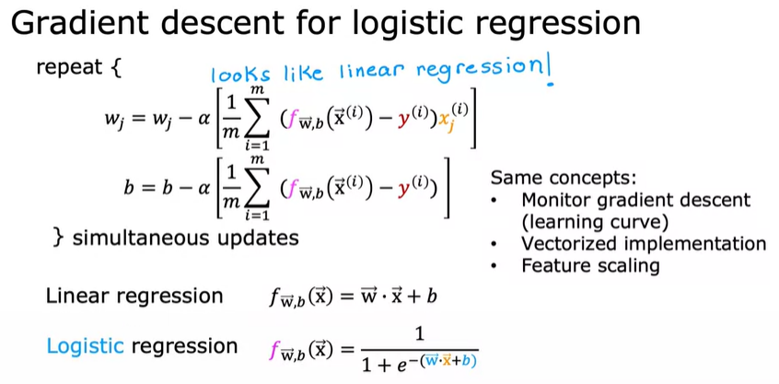

Regularization to Reduce Overfitting

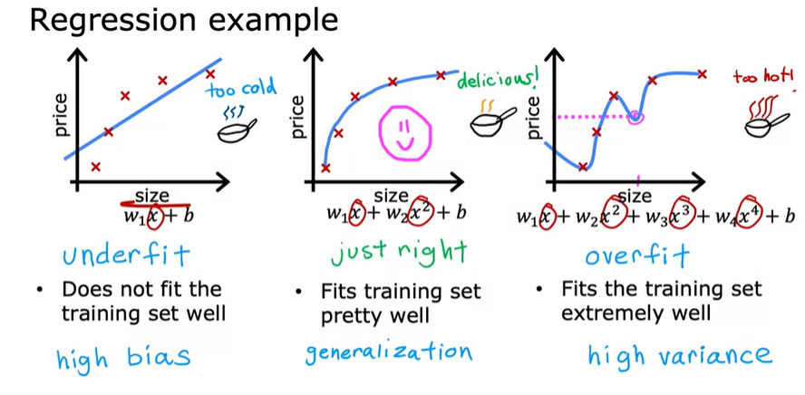

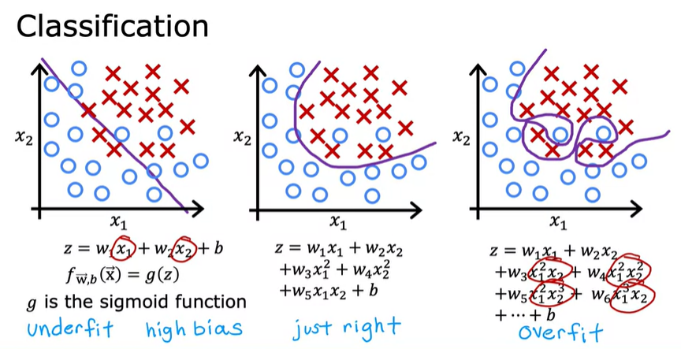

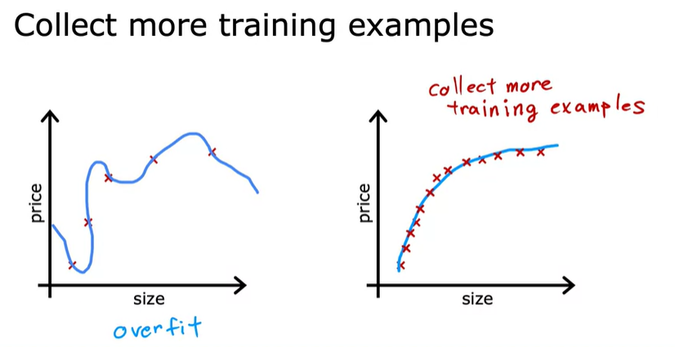

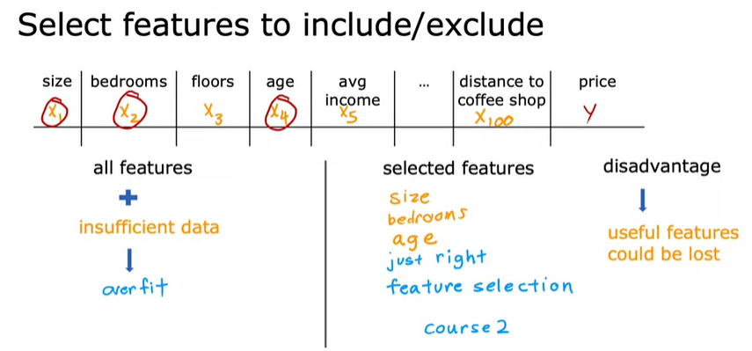

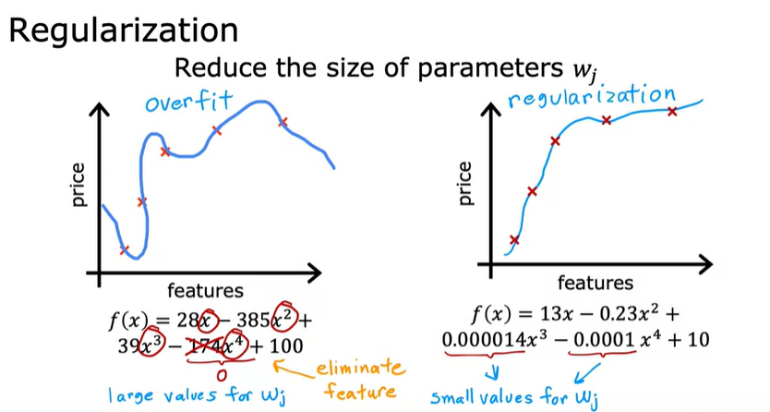

Normally we don’t reduce the value of b



